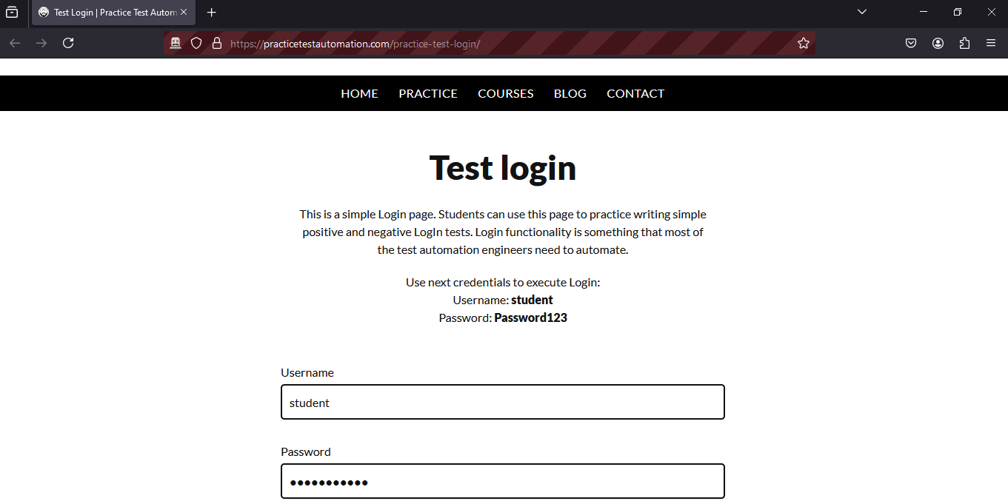
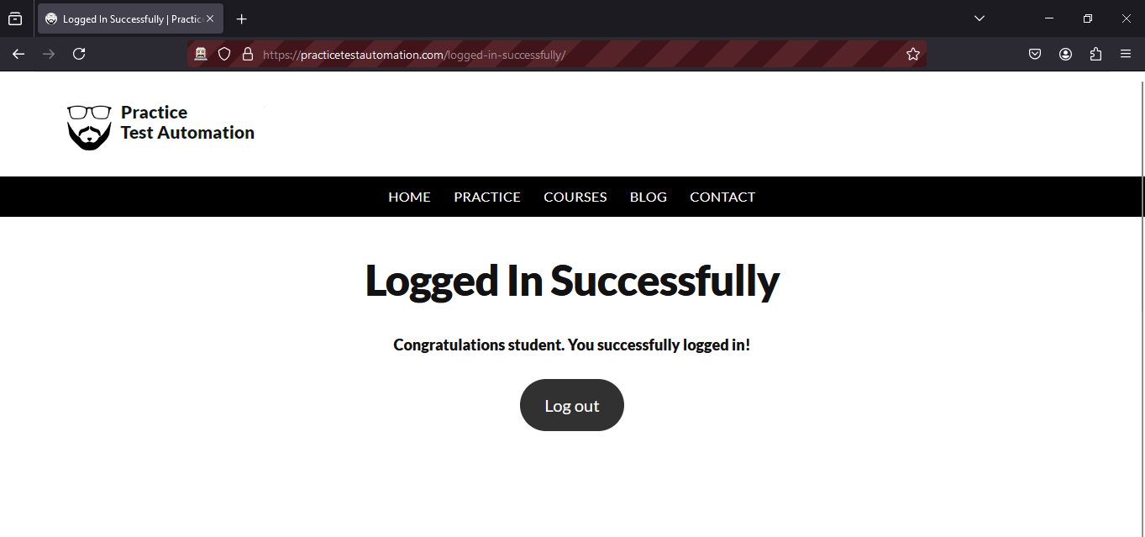
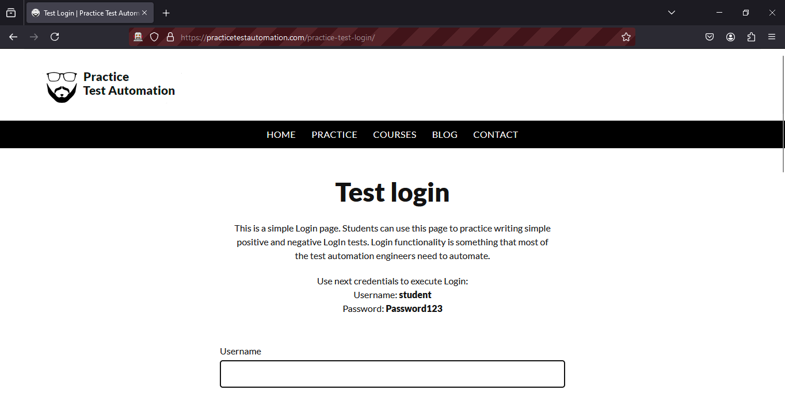


Program No: | 09
Roll No : | 1525
Title of Program : | Bank Account Application
Objective : | Java program to perform bank account operation such as open , withdraw,deposit and check

public class Account {
//data members are also called as instance variable
int acNo;
String acName;
double acBal;
//constructor - three arguments
Account(int acNo,String acName, double acBal) {

this.acNo=acNo;
this.acName=acName;
this.acBal=acBal;
}
//define getters and setters;
int getAcNo()
{
return this.acNo;
}
void setAcNo(int acNo)
{
this.acNo=acNo;
}

String getAcName()
{
return this.acName;
}

double getAcBal(){
return this.acBal;
}
void setAcBal(double acBal)
{
this.acBal=acBal;
}
}

class AccountTest{
public static void main ( String[] args )
{
Account a1 = new Account(101,"ABC",2000);
Account a2 = new Account(102,"PQR",3000);
//first object

System.out.println("Account information");
print(a1);
print(a2);

// System.out.println("Ac No:"+a1.getAcNo());
// System.out.println("Ac Name:"+a1.getAcName());
// System.out.println("Ac Balance:"+a1.getAcBal());

}

static void print (Account temp)
{

System.out.println("Ac No:"+temp.getAcNo());
System.out.println("Ac Name:"+temp.getAcName());
System.out.println("Ac Balance:"+temp.getAcBal());
}




